A Mini Project Report

On

**BANKING SYSTEM**

By

**ADITYA MOGILI**

**1602-19-733-125**

**BAKSHI ABHINITH**

**1602-19-733-124**



**Department of Computer Science & Engineering**

**Vasavi College of Engineering (Autonomous)**

**(Affiliated to Osmania University)**

**Ibrahimbagh, Hyderabad-31**

**2020 - 21**

**ACKNOWLEDGEMENT**

With immense pleasure, we record our deep sense of gratitude to our guide Dr. D Baswaraj, Professor, Vasavi College of Engineering, Hyderabad, for the valuable guidance and suggestions, keen interest and thorough encouragement extended throughout the period of project work.

I consider myself lucky enough to be part of this project. This project would add as an asset to my academic profile.

We express our thanks to all those who contributed for the successful completion of our project work.

**OBJECTIVE**

This System allows the customers to perform banking operations such as Deposit, Withdraw, Bank transfer, Display Transaction details and Transaction history.

**INTRODUCTION**

Online banking is the term used for the process by which a customer may perform banking operation remotely without visiting the Bank. Online banking, also known as virtual banking, internet banking or personal computer banking is an activity that is not new to banks or their customers. Banks have been providing their services to their customers electronically to their customers through software programs which helps the customers directly connect with the bank. In recent times, Cyber-attacks have also increased drastically which makes the customer privacy an important concern.

**ABSTRACT**

Banking sector is one of the fastest growing sectors and has been one of the most preferred avenues of employment. The days of running around a bank for receiving cheques and performing transactions has become a thing of the past. It has now become hassle free and just a click away. Most of the leading banks are going online which makes security the prime concern due to increasing cyber-crimes.

In our project, firstly, the user must register himself with our bank and login to his account to have access to all the functionalities we provide. After logging in successfully, he is provided with options like Deposit, Withdraw, Transfer, Display user details, Display Transaction details etc.,

This system is very convenient to all the users as we provide most of the facilities that a banking system provides to its customers. Moreover, we provide the customers the maximum security as we encrypt their personal information and store it.

**SYSTEM REQUIREMENTS**

**Hardware:**

* Minimum RAM required: 512 mb
* Minimum disk space required: 50 mb
* Input devices: Mouse, Keyboard
* Output devices: Monitor

**MODULES USED**

* Customer Login
* Deposit
* Withdraw
* Transfer

**PROGRAM**

#include<stdio.h>

#include<string.h>

#include<stdlib.h>

#include<time.h>

char name_arr[20][20];

char phone[20][20];

char userName_arr[20][20];

int UID[20];

int pass_shift_arr[20];

char password_arr[20][20];

int arr_cnt = 0;

double transaction_arr[20][100];

int transaction_arr_count[20];

char transaction_arr_Str[20][100][1000];

double curr_bal[20];

int Existing_user(int uid,char pass[])

{

printf("\nuid : %d ; pass : %s",uid,pass);

int ind = -1;

for(int i=0;i<sizeof(UID);i++)

{

if(UID[i] == uid)

{

ind = i;

break;

}

}

if(ind >= 0)

{

//char* decrypt_pass = Decrypt(password_arr[ind],pass_shift_arr[ind]);

//strcpy(decrypt_pass,Decrypt(password_arr[ind],pass_shift_arr[ind]));

//strcpy(password_arr[ind],decrypt_pass);

if(strcmp(password_arr[ind],pass) == 0)

{

return 1;

}

else

{

return 2;

}

}

else

{

return 3;

}

}

void Register_user()

{

printf("PLEASE WAIT...");

printf("ENTER YOUR DETAILS: \n");

printf("ENTER YOUR NAME: ");

scanf("%s",name_arr[arr_cnt]);

printf("ENTER YOUR PHONE NUMBER: ");

scanf("%s",phone[arr_cnt]);

printf("SELECT YOUR USERNAME: ");

scanf("%s",userName_arr[arr_cnt]);

srand(time(0));

int uid_gen = (rand() % (100000 - 999999)) + 999999;

printf("YOU USER ID IS: %d\n",uid_gen);

UID[arr_cnt] = uid_gen;

printf("\nENTER YOUR PASSWORD: ");

char user_pass[20];

scanf(" %s",user_pass);

//gets(user_pass);

int rand_shift = (rand() % (0 - 25)) + 25;

//printf("hello");

//int rand_shift = 25;

//char* user_pass_encrypt = Encrypt(user_pass , rand_shift);

//System.out.println("create user shift:"+rand_shift);

pass_shift_arr[arr_cnt] = rand_shift;

strcpy(password_arr[arr_cnt],user_pass);

printf("PLEASE WAIT WHILE WE CREATE YOUR ACCOUNT...\n");

printf("ACCOUNT CREATED SUCCESSFULLY!!\n");

arr_cnt += 1;

}

void Deposit(int uid)

{

int ind = -1;

for(int i=0;i<sizeof(UID);i++)

{

if(UID[i] == uid)

{

ind = i;

break;

}

}

printf("ENTER THE AMOUNT YOU WANT TO DEPOSIT: \n");

double add_bal;

scanf("%lf",&add_bal);

int existing_vars = transaction_arr_count[ind];

//System.out.println("ex:"+existing_vars);

transaction_arr[ind][existing_vars] = add_bal;

strcpy(transaction_arr_Str[ind][existing_vars],"Deposit");

printf("PREVIOUS BALANCE: Rs. %lf\n",curr_bal[ind]);

curr_bal[ind] += add_bal;

printf("\nPROCESSING");

printf("DONE.\n");

printf("TRANSACTION SUCCESSFUL.\n");

printf("\n");

printf("CURRENT BALANCE: Rs. %lf \n",curr_bal[ind]);

transaction_arr_count[ind]++;

}

void WithDraw(int uid)

{

int ind = -1;

for(int i=0;i<sizeof(uid);i++)

{

if(UID[i] == uid)

{

ind = i;

break;

}

}

printf("CURRENT BALANCE: Rs. %lf\n",curr_bal[ind]);

/*System.out.println("Enter the amount you want to Withdraw from your account:");*/

double del_bal = 0.0;

do

{

printf("ENTER THE AMOUNT YOU WANT TO WITHDRAW: \n");

scanf("%lf",&del_bal);

if(del_bal <= curr_bal[ind])

{

break;

}

else

{

printf("INSUFFICIENT BALANCE :( \nTRY AGAIN\n");

continue;

}

}while(1);

del_bal *= -1;

int existing_vars = transaction_arr_count[ind];

transaction_arr[ind][existing_vars] = del_bal;

strcpy(transaction_arr_Str[ind][existing_vars],"Withdraw");

curr_bal[ind] += del_bal;

printf("PROCESSING...\n");

printf("TRANSACTION SUCCESSFUL :)\n");

printf("NEW BALANCE: Rs. %lf\n",curr_bal[ind]);

transaction_arr_count[ind]++;

}

void TransferAmount(int giver_id)

{

int giver_ind = -1;

for(int i=0;i<sizeof(UID);i++)

{

if(UID[i] == giver_id)

{

giver_ind = i;

break;

}

}

int rec_ind = -1;

do

{

int rec_id;

printf("ENTER THE USER ID TO WHICH YOU WANT TO TRANSFER TO: \n");

scanf("%d",&rec_id);

int ind1 = -1;

for(int i=0;i<sizeof(UID);i++)

{

if(UID[i] == rec_id)

{

ind1 = i;

break;

}

}

if(ind1 >= 0)

{

rec_ind = ind1;

break;

}

else

{

printf("\tUSER ID NOT FOUND :(\n\tDO YOU WANT TO TRY AGAIN?\n\t1.YES\t2.NO\n");

int ch;

scanf("%d",&ch);

if(ch == 1)

{

continue;

}

else

break;

}

}while(1);

double tran_amt = 0;

if(rec_ind >=0)

{

printf("CURRENT BALANCE: Rs. %lf\n",curr_bal[giver_ind]);

//double tran_amt = 0;

do

{

printf("ENTER THE AMOUNT YOU WANT TO TRANSFER: \n");

//scanf("%lf",&tran_amt);

scanf("%lf",&tran_amt);

if(tran_amt <= curr_bal[giver_ind])

{

break;

}

else

{

printf("INSUFFICIENT BALANCE :(\nTRY AGAIN\n");

continue;

}

}while(1);

int existing_vars = transaction_arr_count[giver_ind];

transaction_arr[giver_ind][existing_vars] = (-1)*tran_amt;

//char buf[10];

// char buf1[10];

// itoa(tran_amt,buf,10);

// itoa(UID[rec_ind],buf1,10);

strcpy(transaction_arr_Str[rec_ind][existing_vars],"TRANSFER");

curr_bal[giver_ind] += (-1)*tran_amt;

transaction_arr_count[giver_ind]++;

int existing_vars1 = transaction_arr_count[rec_ind];

transaction_arr[rec_ind][existing_vars1] = tran_amt;

strcpy(transaction_arr_Str[rec_ind][existing_vars1],"TRANSFER");

curr_bal[rec_ind] += tran_amt;

transaction_arr_count[rec_ind]++;

printf("\nPROCESSING");

printf("TRANSACTION SUCCESSFUL :)\n");

}

}

void main()

{

int login_var;

do

{

printf("\n\t*****YES BANK******\n\n");

printf("\t1.LOGIN\n\t2.REGISTER\n\t3.EXIT\n");

int login_var;

scanf("%d",&login_var);

if(login_var == 1)

{

int login_conf;

printf("ENTER YOUR DETAILS: \n");

printf("USER ID: \n");

int user_id;

scanf("%d",&user_id);

printf("PASSWORD: \n");

char password[20];

scanf("%s",password);

login_conf = Existing_user(user_id,password);//day1

printf("AUTHENTICATING..");

if(login_conf == 1)

{

printf("\nLOGIN SUCCESSFUL!!\n");

printf("GETTING STARTED");

int check_ctr = 1;

do

{

int switch_var;

printf("\n\tAVAILABLE OPTIONS IN OUR BANKING SYSTEMS:\n");

printf("\t1.DEPOSIT\n\t2.WITHDRAW\n\t3.TRANSFER TO ANOTHER USER\n\t4.DISPLAY USER DETAILS\n\t5.DISPLAY TRANSACTION DETAILS\n\t6.LOG OUT\n\n");

scanf("%d",&switch_var);

switch(switch_var)

{

case 1:

//Implementing deposit Module;

Deposit(user_id);

break;

case 2:

//Implementing withdraw module;

WithDraw(user_id);

break;

case 3:

//Implementing transfer module;

TransferAmount(user_id);

break;

/*case 4:

//Implementing user details display module;

User_Details(user_id);

break;

case 5:

//Implementing transaction details display module;

Transaction_Details(user_id);

break;*/

case 6:

printf("LOGGING OUT..\n");

printf("DONE!!\n");

printf("THANK YOU FOR USING OUR SERVICES.\nLOOKING FORWARD TO HELP YOU :)\n");

check_ctr = 0;

break;

}

}while(check_ctr > 0);

}

else if(login_conf == 2)

{

printf("INCORRECT PASSWORD :( \nPLEASE TRY AGAIN \n");

continue;

}

else if(login_conf == 3)

{

printf("USER ACCOUNT DOES NOT EXIST :(");

int reg_conf;

printf("DO YOU WANT TO CREATE A NEW ACCOUNT?\n1.YES\t2.NO");

scanf("%d",&reg_conf);

if(reg_conf == 1)

{

Register_user();

}

else

{

printf("THANK YOU FOR USING OUR SERVICES.\nLOOKING FORWARD TO HELP YOU :)\n");

}

}

}

else if(login_var == 2)

{

printf("HI , WELCOME TO YES BANK :)\n");

Register_user();

printf("\n");

}

else

{

printf("THANK YOU!!");

exit(0);

}

}while(1);

}

**OUTPUT OF THE PROGRAM**

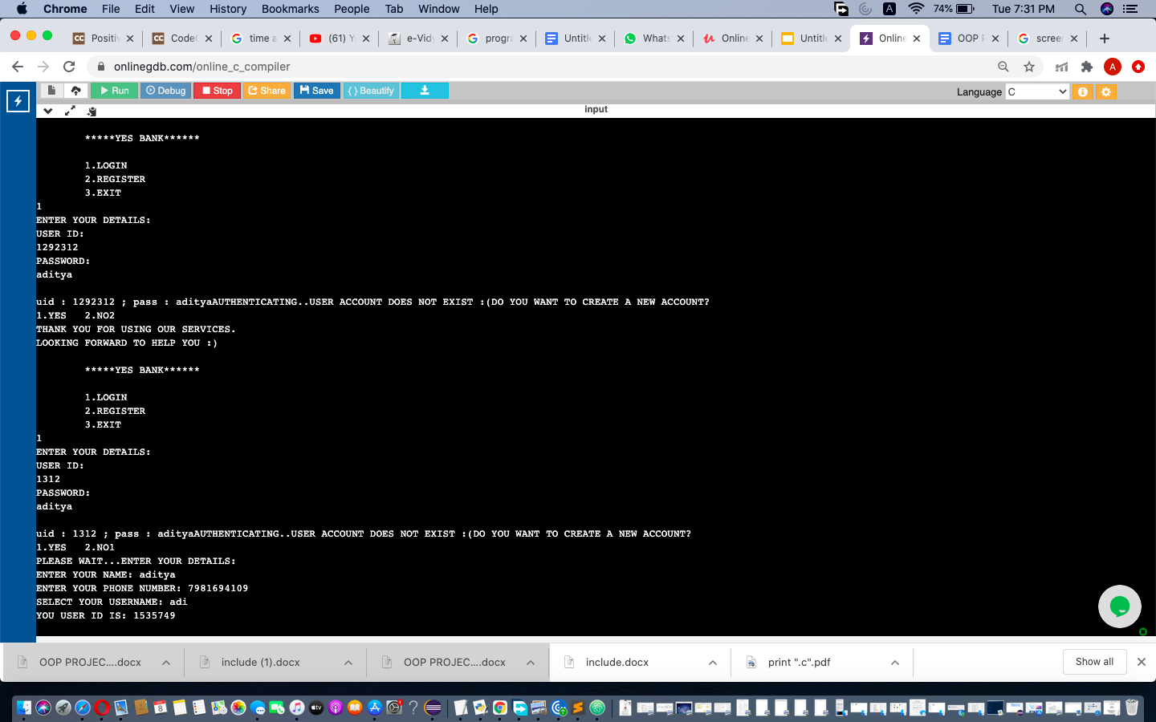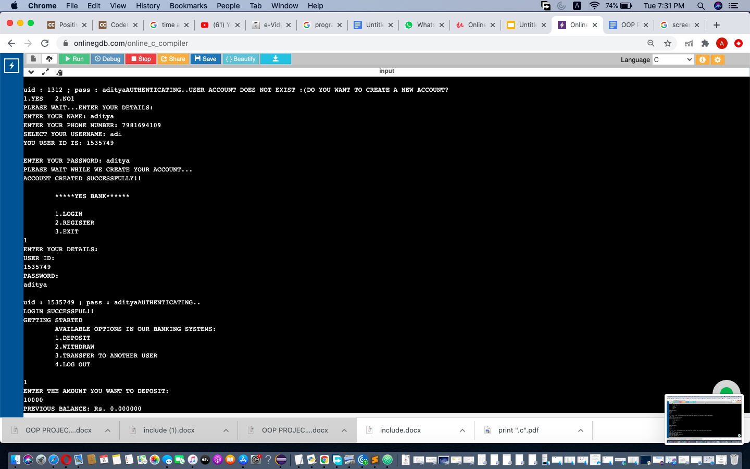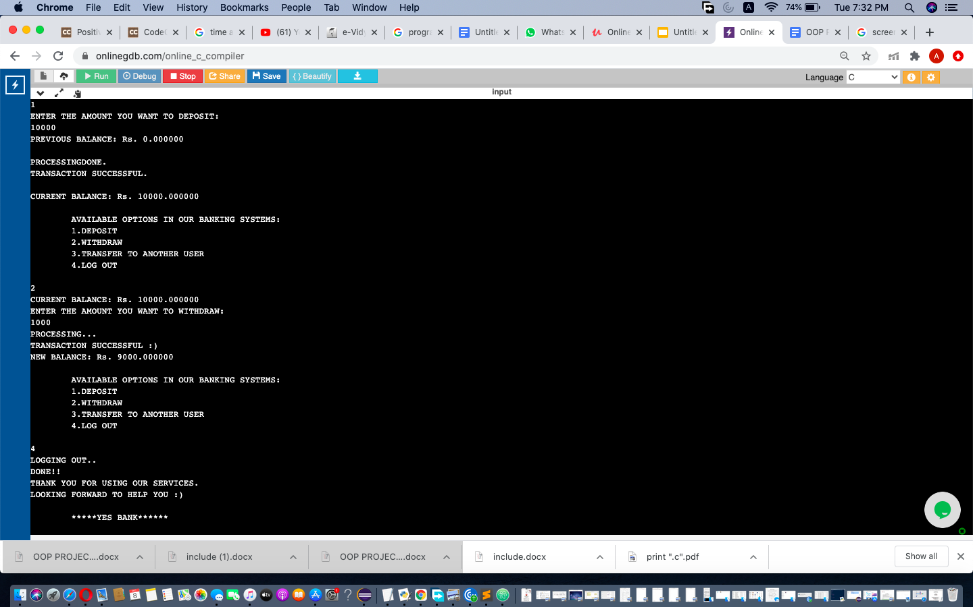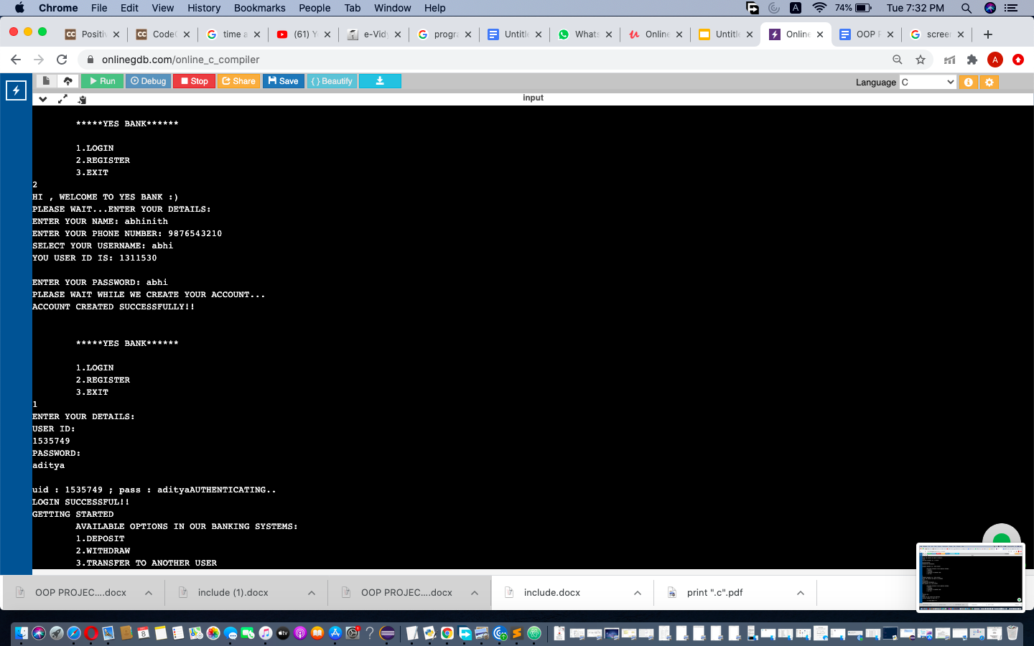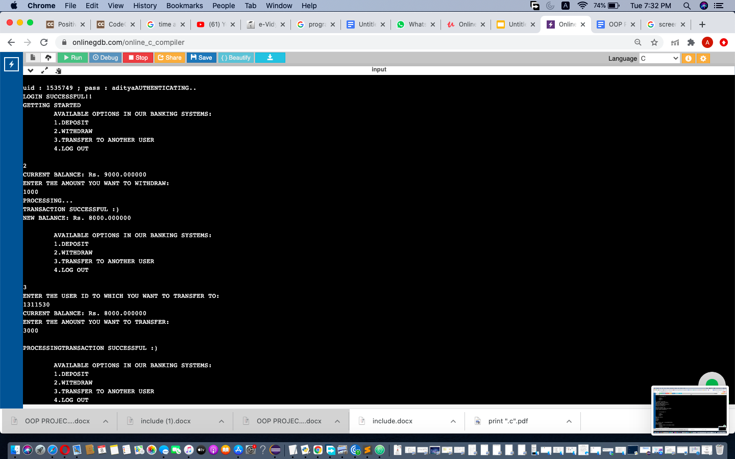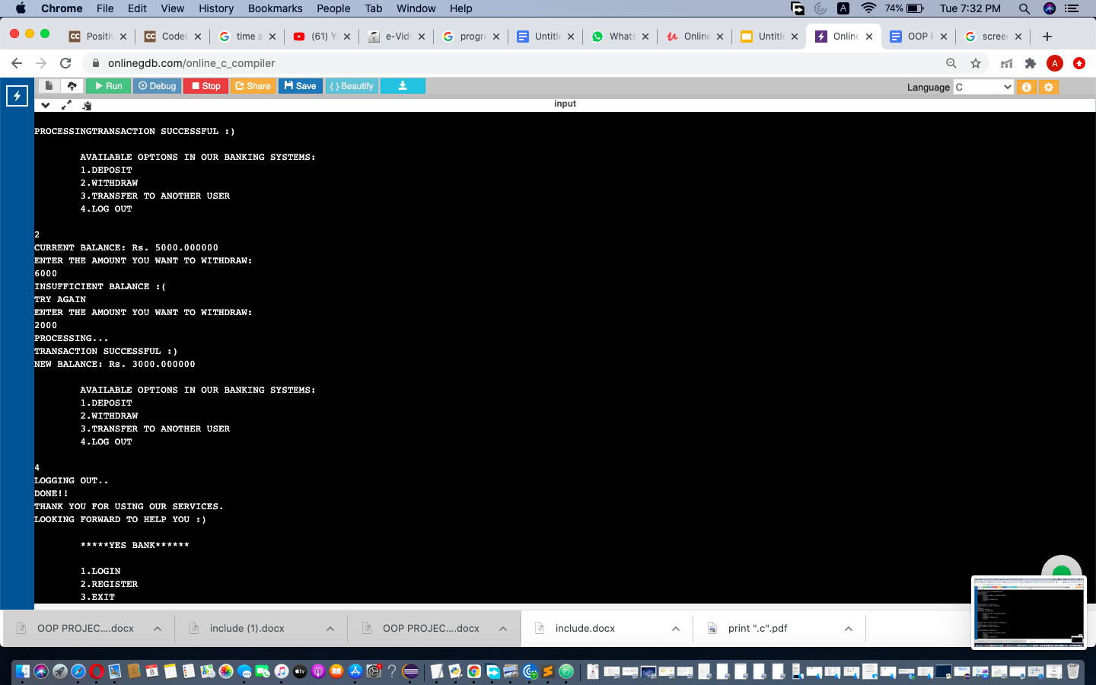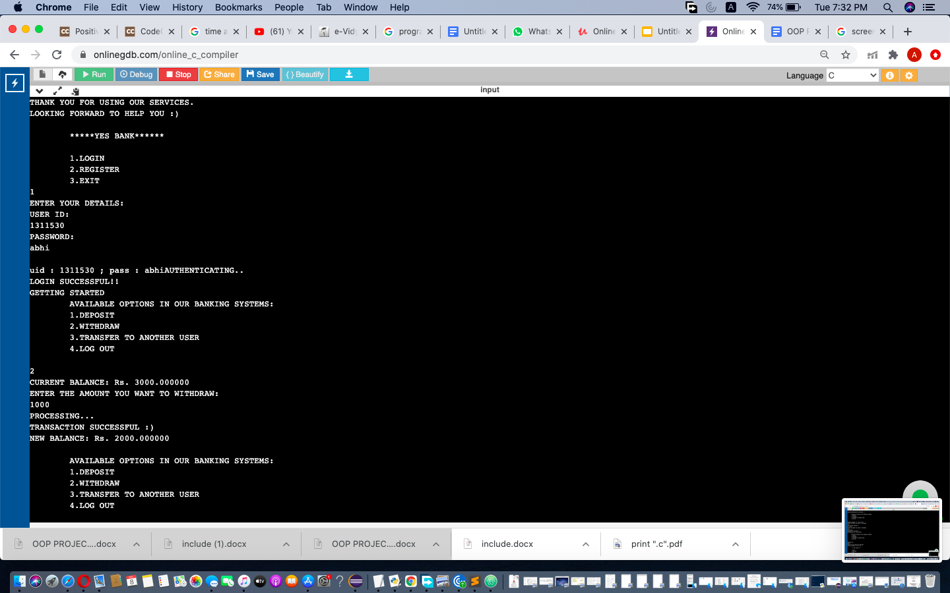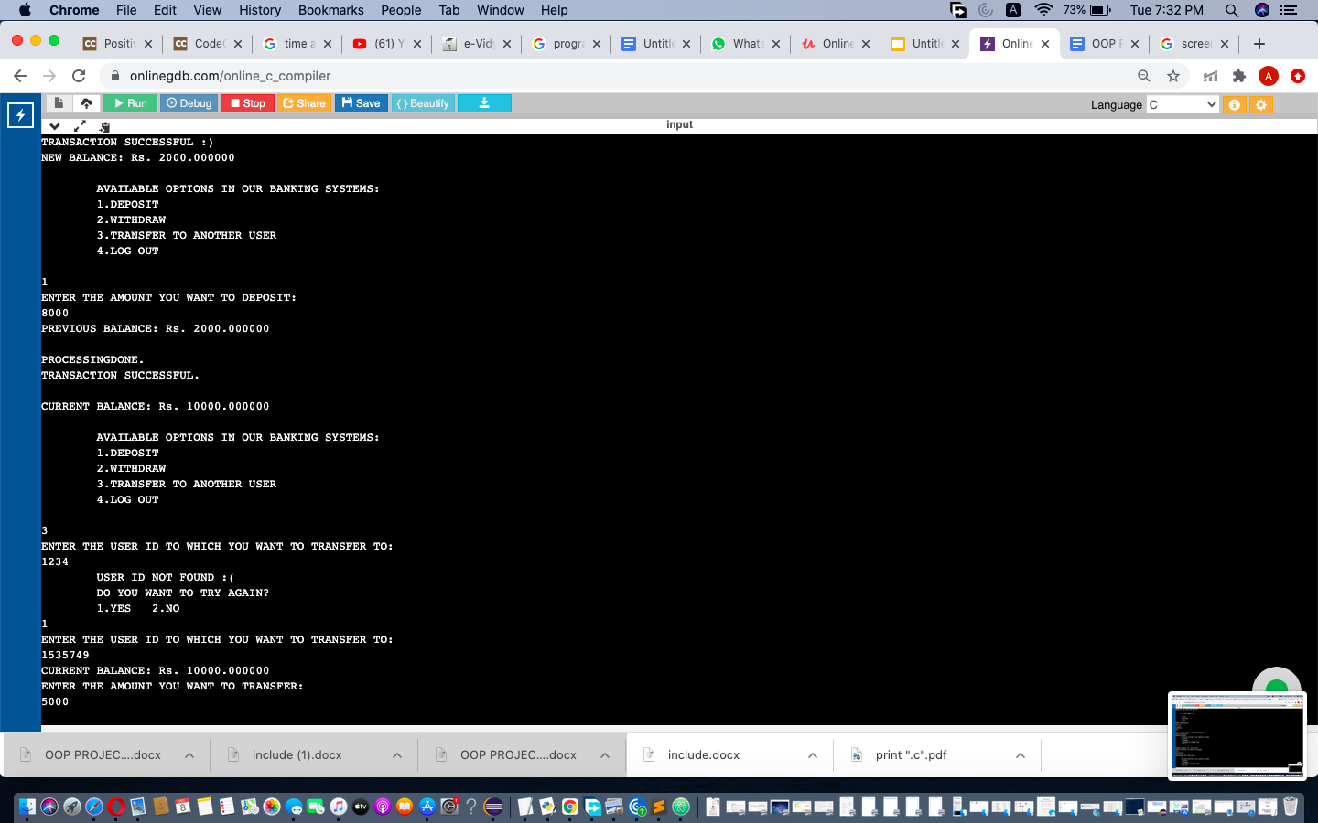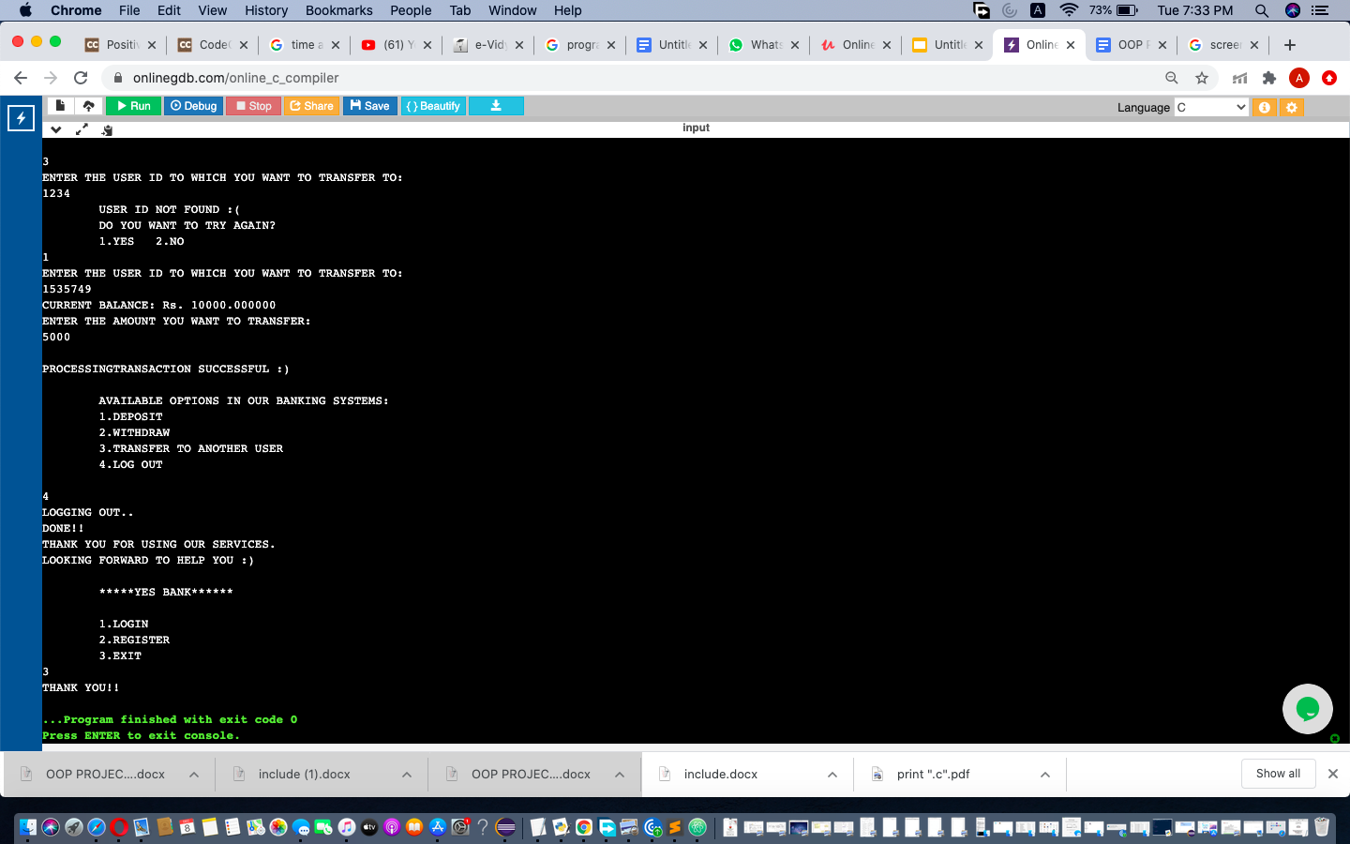

**FUTURE WORK**

We would like to extend this project by adding real time data storage applications using an online Database service such as MySQL.

**REFERENCES**

* <https://stackoverflow.com/>
* [**https://www.geeksforgeeks.com**](https://www.geeksforgeeks.com)
* **https://www.w3adda.com/c-tutorial**
* **https://www.programiz.com/**